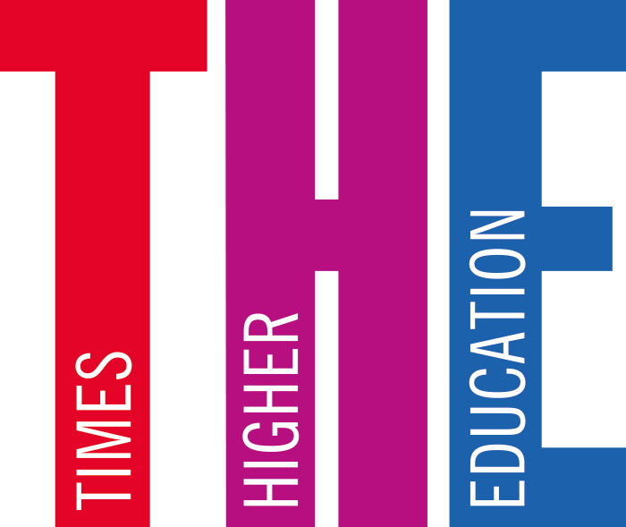

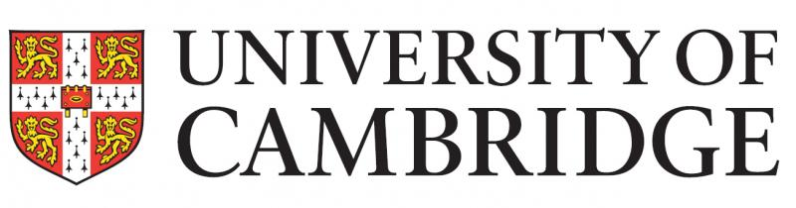

THE UNIVERSITY OF CAMBRIDGE NOW HAS AN INSTITUTION-WIDE LICENCE TO

THE TIMES HIGHER EDUCATION (THE).

Staff and students keen to keep up to date with developments within the higher education sector can do so courtesy of a new institutional subscription to the *Times Higher Education* (*THE)* magazine.

The University has signed a three-year deal that enables staff and students to read the magazine online. This licence allows all staff and students to access a range of editorial services, including:

* regular newsletter updates
* weekly digital editions of *THE* magazine
* unrestricted access to *THE* online and via its app.

Individuals can find details on how to create their account on the University Library’s *THE*page:

<https://www.libraries.cam.ac.uk/eresources/newspapers/british-newspapers/times-higher-education>