

**New eResources in American History**

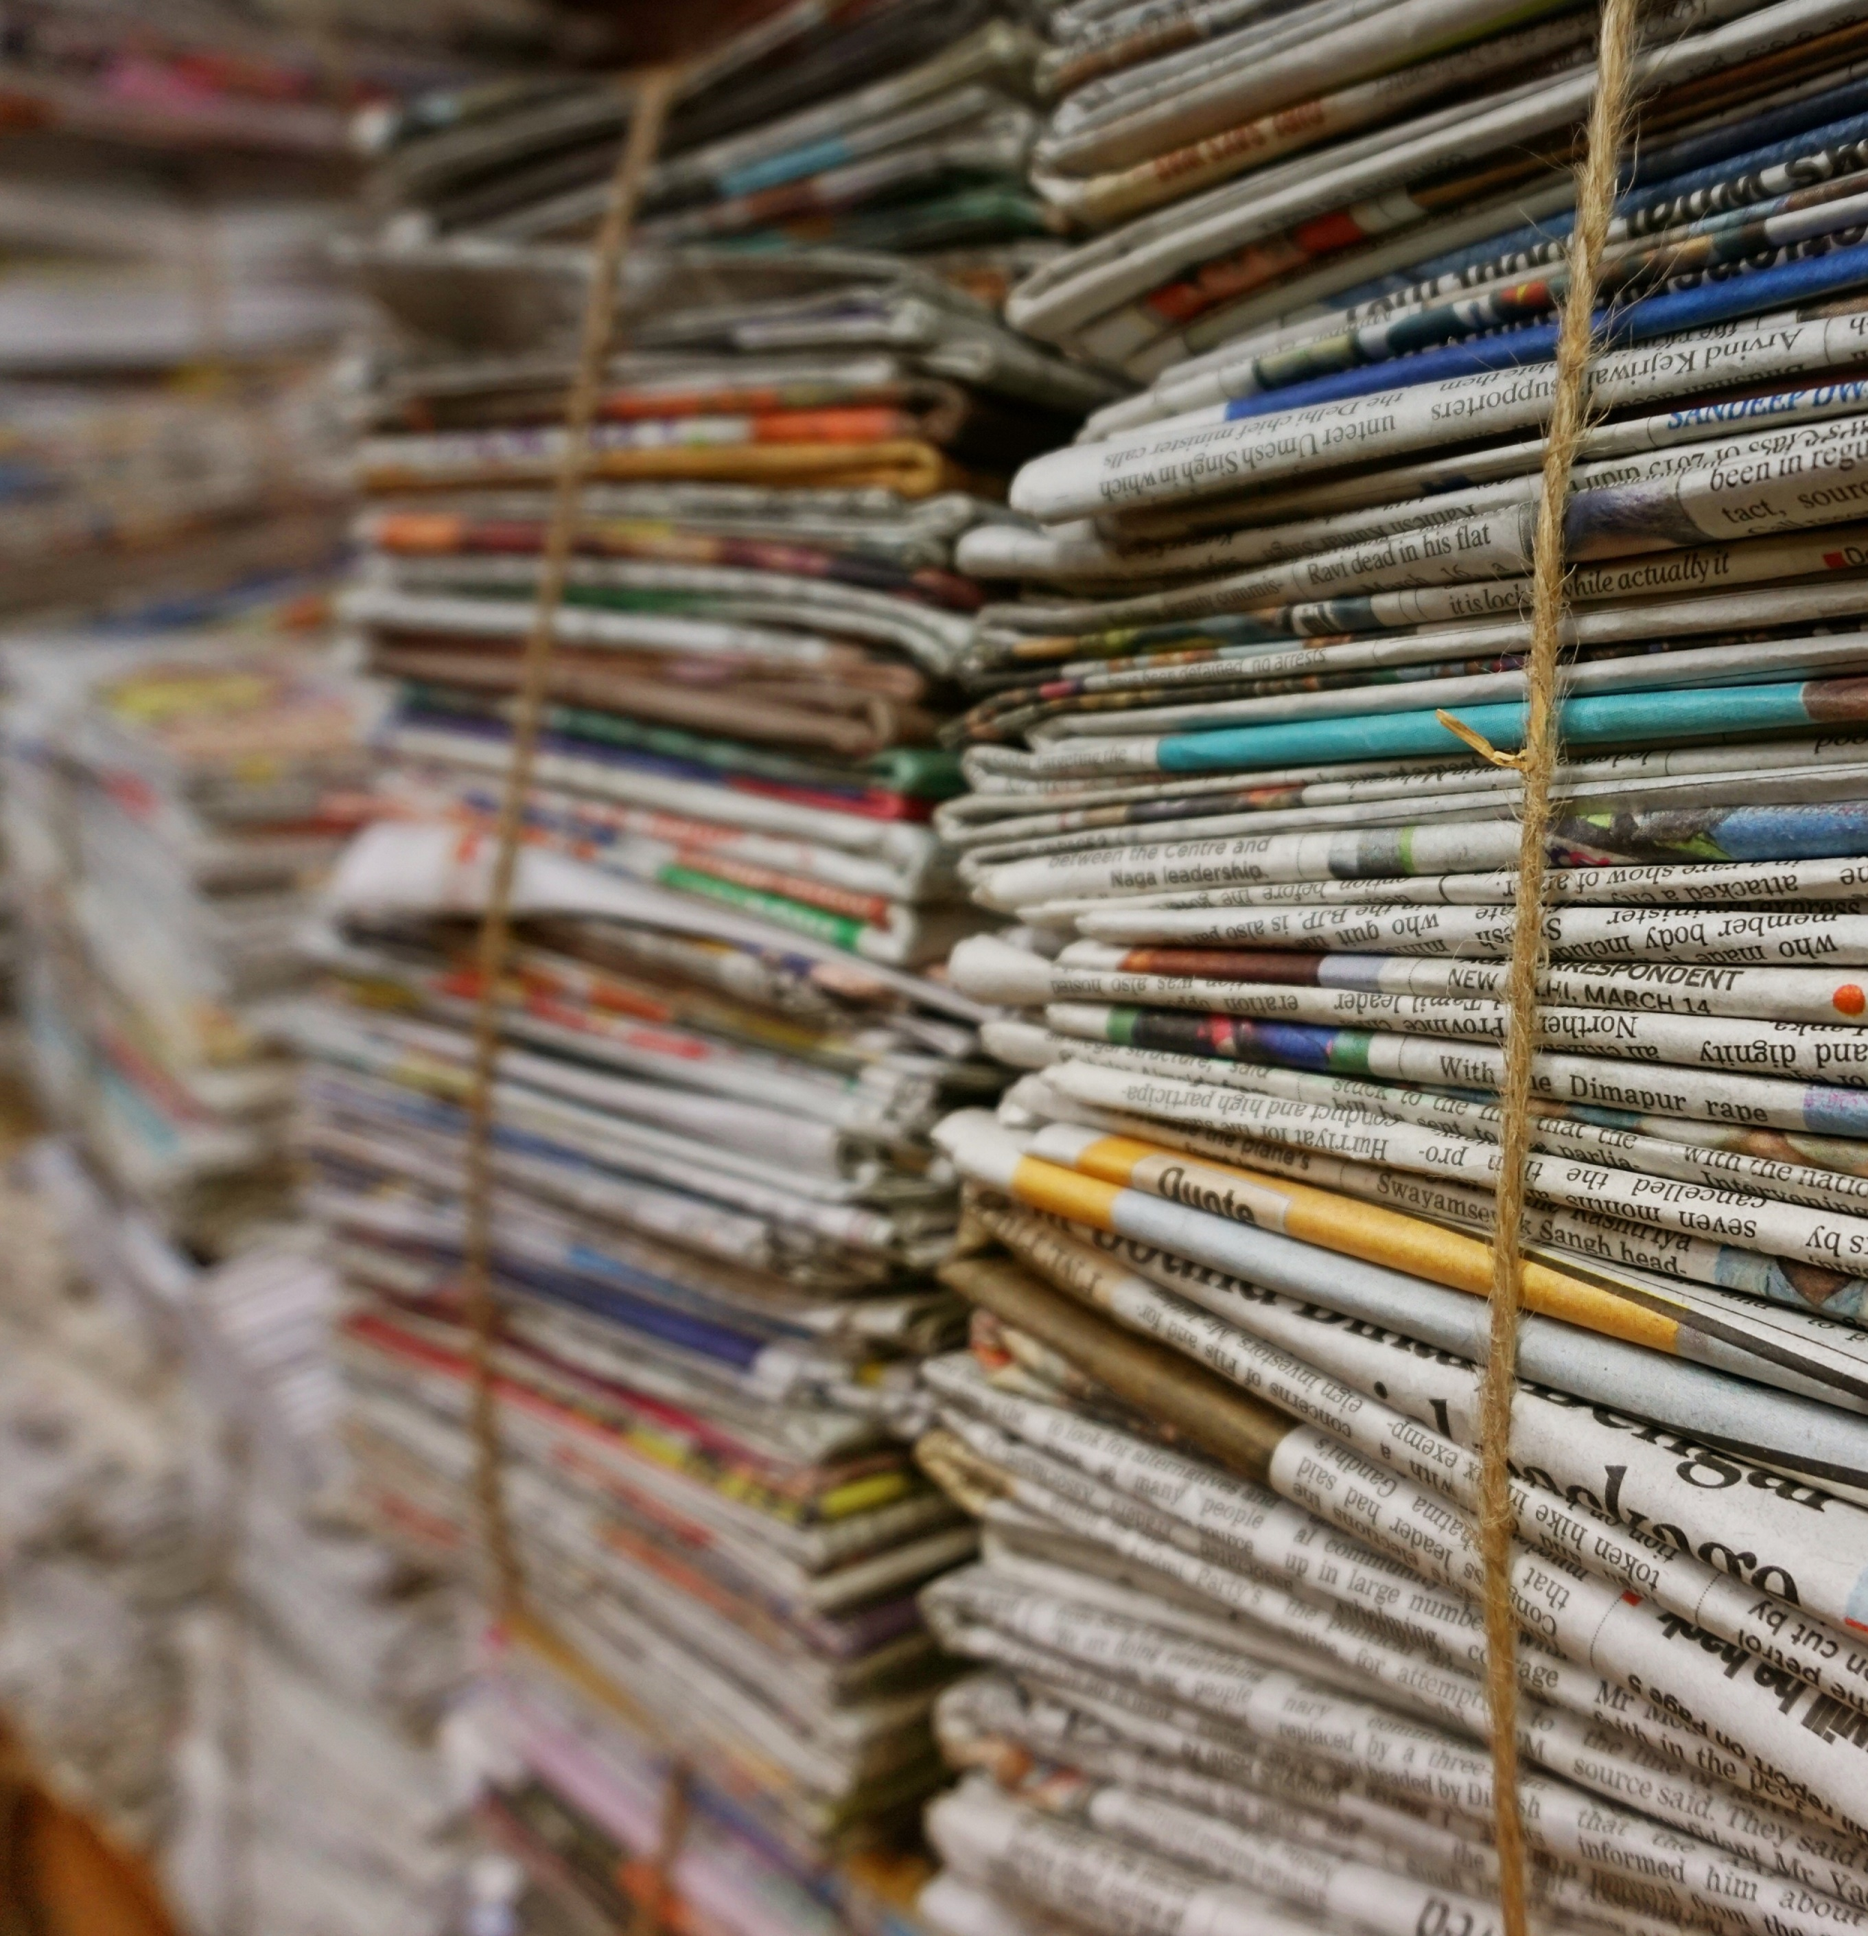

### Access is now available to 3 ProQuest digital archives in American History



**Historical local, regional and national news coverage from 1849 to 1995.**

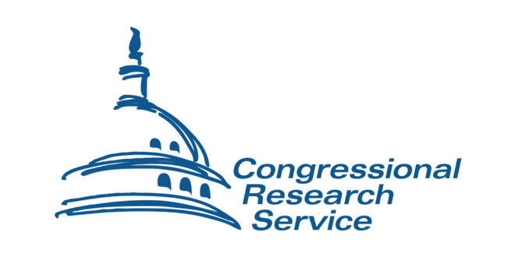

**Congressional Record Permanent Digital Collection,**

**& Congressional Research Digital Collection**

**Access is available from the Databases A-Z:**

**http://libguides.cam.ac.uk/az.php**